|  |  |  |  |  |  |
| --- | --- | --- | --- | --- | --- |
| Date | 1-Dec-22 | | | Tester Name | Andrew McLaughlin |
| Environment | Penfax - Test | | | Login used |  |
| Operating System | Select OS | Version: | Update: | | |
| Software Used | Select Software | Version: | Update: | | |
| Select Software | Version: | Update: | | |
| Release version | 22.4.1 | | | | |
| Title | Pays member correctly by EFT | | | | |
| Test Type | Regression | | | | |
| Test Scenario | Pays member correctly by EFT | | | | |
|  |  | | | | |
| Expected Results |  | | | | |
| Pass/Fail | Pass | | | JIRA# | N/A |

Describe your steps with screenshots:

Member has an EFT Payment Instruction Set Up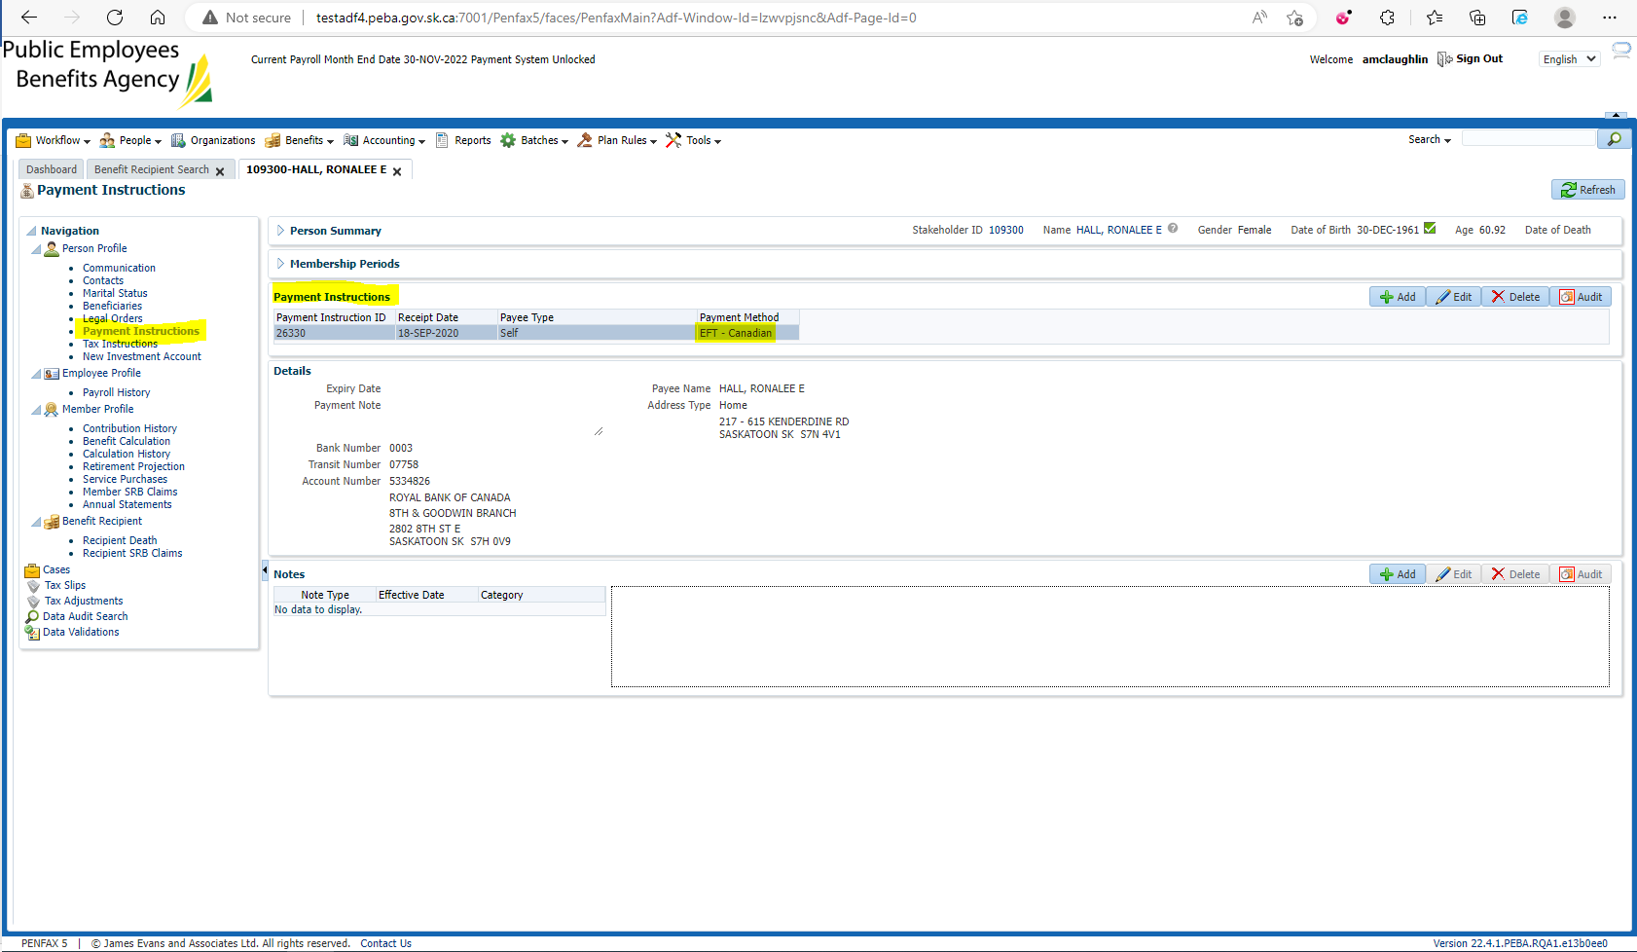

Open the Payment ID of the payment needing to be replaced in Benefit Recipient > Payment History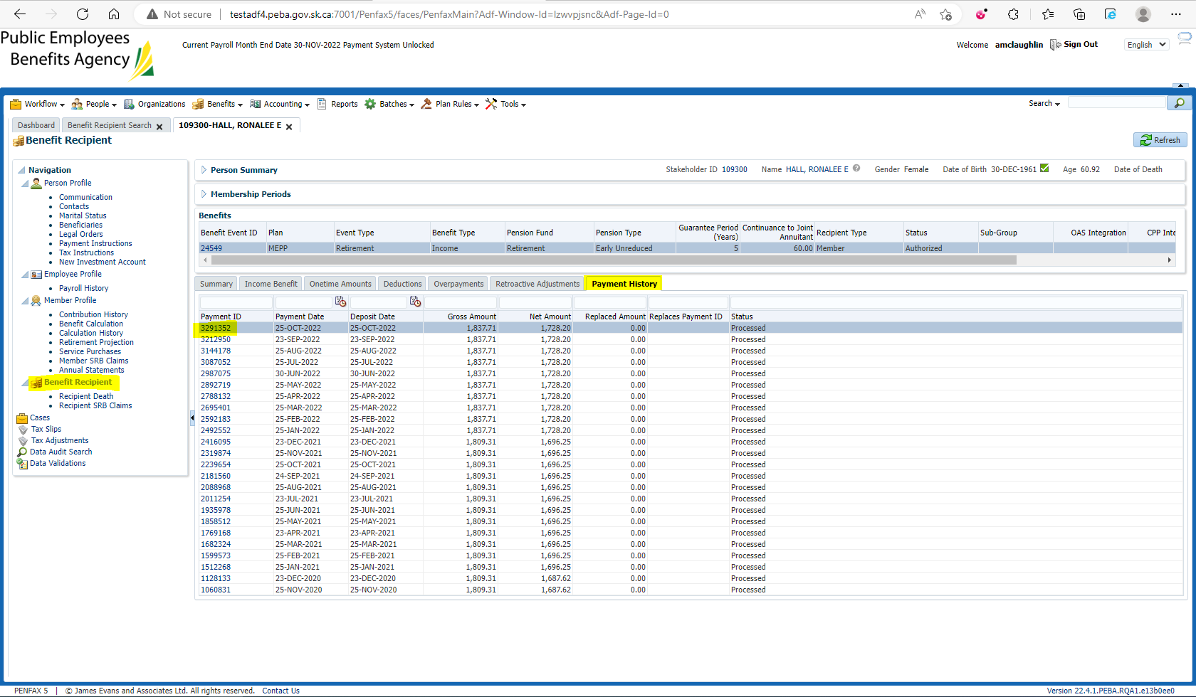

Replace the payment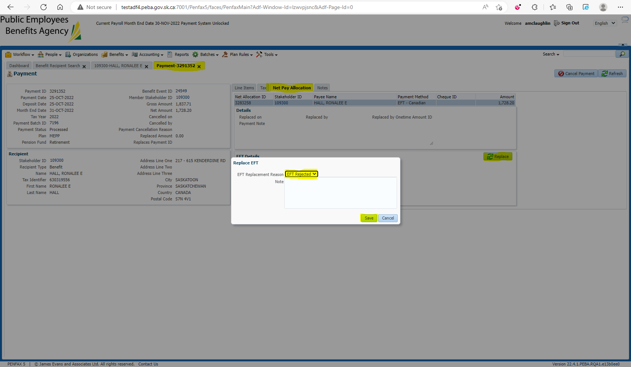

Add payment/tax instructions, Submit for Approval and Approve the Replacement Payment created under Onetime Amounts tab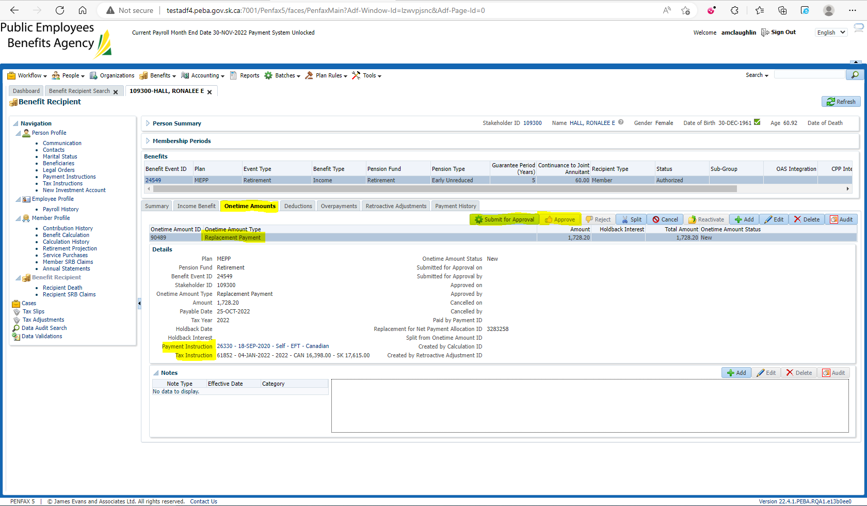

Wait for the overnight payroll to run and then check the member’s Payment History to ensure the replacement payment has been issued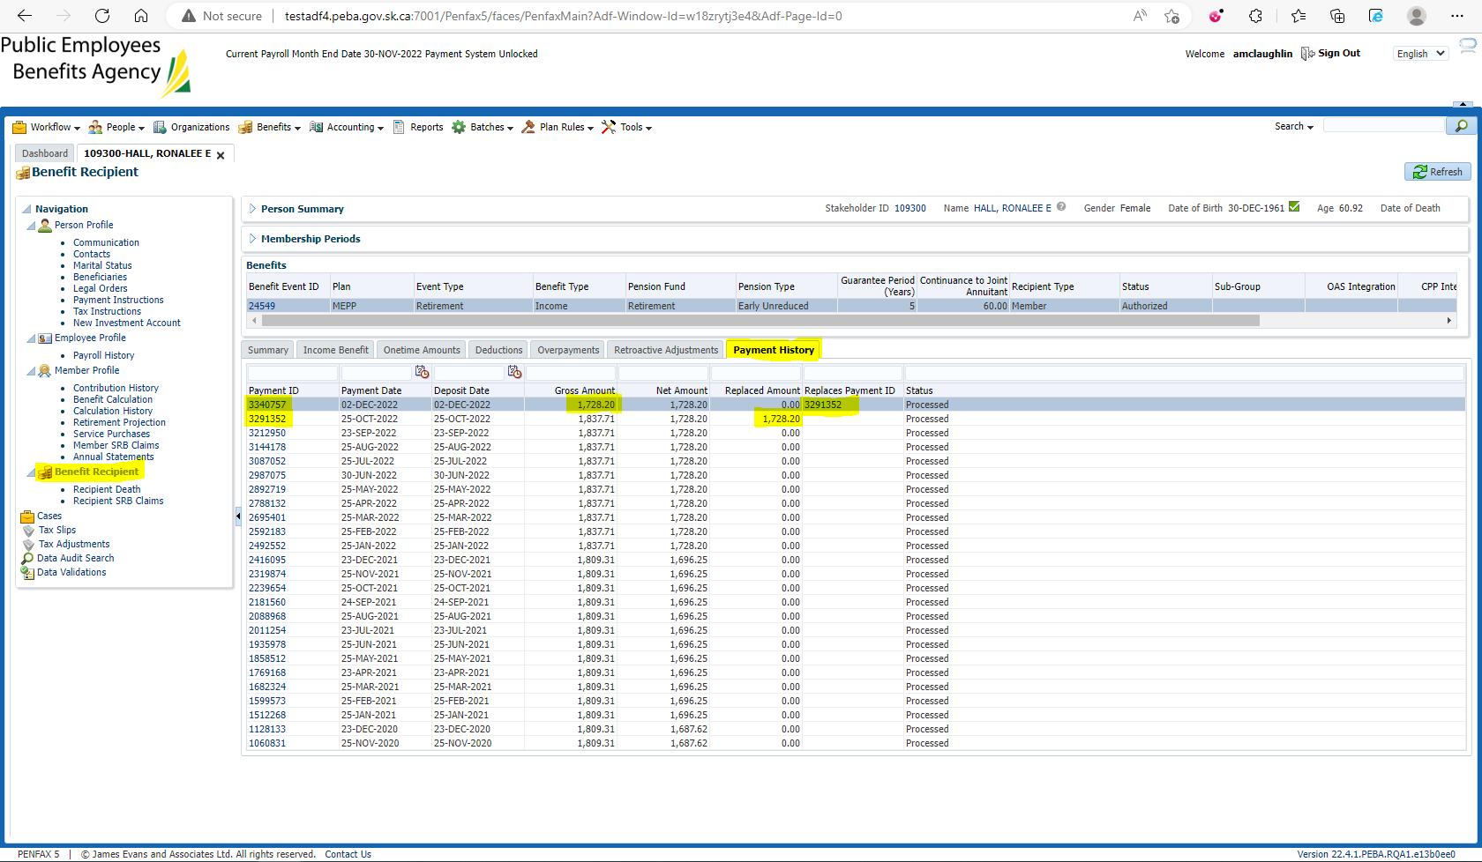

The new payment was replaced by EFT